RESOLUTION NO.__________

RE: CERTIFICATE OF APPROPRIATENESS UNDER THE
PROVISIONS OF THE ACT OF THE PENNSYLVANIA
LEGISLATURE 1961, JUNE 13, P.L. 282 (53
SECTION 8004) AND BETHLEHEM ORDINANCE NO.
3952 AS AMENDED.

WHEREAS, it is proposed to retain white adhesive lettering in Times New Roman font depicting the name and telephone number of the company at 700 Evans Street.

NOW, THEREFORE, BE IT RESOLVED by the Council of the City of Bethlehem that a Certificate of Appropriateness is hereby granted for the proposal.

Sponsored by: (s)

(s)

ADOPTED BY COUNCIL THIS DAY OF

(s)
President of Council

ATTEST:

(s)
City Clerk

HISTORIC CONSERVATION COMMISSION

CASE #645 -- It is proposed to retain white adhesive lettering in Times New Roman font depicting the name and telephone number of the company on the inside surface of two first-floor windows at 700 Evans Street.
OWNER/APPLICANT: GSE Realty, Inc./Michael Renneisen

The Commission upon motion by Mr. Evans and seconded by Ms. Starbuck adopted the proposal that City Council issue a Certificate of Appropriateness for the proposed work as described herein:

- The proposal to retain white adhesive lettering in Times New Roman font depicting the name and telephone number of the company at 700 Evans Street was presented by Michael Renneisen.
- The existing vinyl serif lettering applied to the inside surface of two entry-level windows advertises the company name and telephone number of Attorney Michael Renneisen. Ideally, window lettering should be smaller in scale and applied within the upper third portion of glazed windows rather than the current centered location. Mr. Renneisen agreed to return to HCC with any proposed future signage prior to installation.
- The motion for the proposed work was unanimously approved.

JBL: jbl
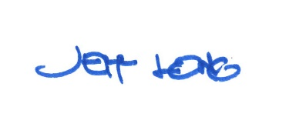

By:

Date of Meeting: April 17, 2018 Title: Historic Officer

